Overview

Project Type
Educational redesign of a real skincare studio’s website, guided by mentor feedback and supported by user research.

Task
Redesign the entire Saving Faces website to improve usability, trust, and clarity of services.

Problem statement/ problem summary
The existing website lacked clear service categorization, had a confusing navigation structure, provided insufficient trust signals, and delivered a fragmented booking flow.

Goals
- Enhance clarity and organization of services
- Improve user trust through real reviews and visuals
- Simplify and streamline the booking experience
- Create a cohesive and modern visual identity
- Ensure mobile and desktop responsiveness

About business
Saving Faces is a boutique skincare and beauty studio in Los Angeles offering facial treatments, consultations, and skincare products.

My role
UX/UI Designer — responsible for research, IA, wireframes, visual design, and interaction flows.

Core Issues Observed
- Users couldn’t easily understand which service was right for them
- Descriptions were long or unclear
- No reliable reviews or before/after photos
- Navigation was scattered and inconsistent
- Booking redirected to an external page and restarted
- Lack of clear pricing and esthetician information reduced trust

Business Needs
- Present clear service details
- Build credibility through verified reviews + visuals
- Reduce friction in the booking flow
- Improve user access to product offerings
- Create a cohesive, modern digital presence matching their premium service quality

Design method

Discover

Heuristic Evaluation

Survey

Interview

affinity diagram

Competitive Analysis

card sorting

Define

site map

persona

user flow

Scanario

Which parts to improve/ what should we change

Deliver

Ideation and wireframing
What was the pain point? What is our solution

Usability test and iterations

Design

UI Design

High fidelity design and prototype

Usability test and iteration

0. Overview
- Project Brief
- Problem Statement
- Target Users
- My Role & Timeline
- Tools Used

1. Discover

1.1 Heuristic Evaluation (note: screenshots need to be added.)
We, as a team of 4 conducted a heuristic evaluation to identify usability and trust issues on the original Saving Faces website. Both overall user flow and individual pages were evaluated to see how easily users could achieve their goals.
Method: Used Nielsen’s 10 usability heuristics as a guideline

Key Issues Identified
1. Navigation & Information Architecture
- Services categorization was unclear and incoherent
- Home page lacked a clear menu; hamburger menu on desktop was unnecessary
- Service access paths were confusing, leading to user frustration
2. Content & Visual Clarity
- Service descriptions were too long and unclear
- Fonts and titles were not easily readable
- Icons and links scattered, creating inconsistent visual hierarchy
3. Trust & Credibility
- No reviews displayed on the main website
- No before/after service photos
- Gift card option hidden and unclear
- Users misled to think booking could be done on the main website
4. Functionality & Responsiveness
- Website not responsive for desktop and mobile
- “Call us now” button not easily visible
- Booking redirected to an external site, restarting the process
Insight
Main problem: Poor information architecture and navigation led to confusion about services and booking

1.2 User Interviews
We conducted interviews with 9 potential skincare website users to understand their common needs, expectations, and pain points when exploring services and booking appointments online.
The goal was to learn what information users consider essential, which factors build trust, and how they prefer to navigate and interact with a skincare service website.

1.3 Affinity Diagram
We synthesized the key takeaways from user interviews into an Affinity Diagram to identify critical user needs and pain points.
Key User Needs & Pain Points Identified:
- Clear and concise service descriptions
- Reliable reviews and before/after visuals
- Transparent pricing and esthetician information
- Easy access to services and consultation options
- Visible schedule for booking
The Affinity Diagram highlighted the most critical user needs and served as the foundation for defining IA, user flows, and areas of redesign.
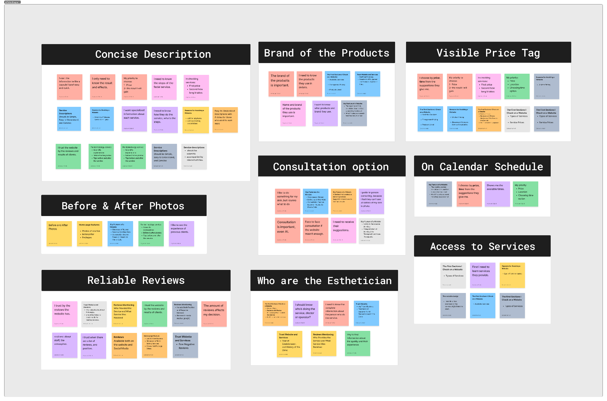

1.4 User Survey
(version 1) To validate user expectations around service selection and website content, we conducted a survey with 37 participants. Results showed that most users had prior facial experience (63%) and strongly relied on professional consultation—95% said they always or sometimes need expert guidance, with in-person consultation being the preferred format (75.8%). When choosing a service independently, users depended mainly on customer reviews (48.6%) and clear, concise service descriptions. Their first step in the decision process was typically online research (48.6%), and the most helpful website feature was a personalized recommendation tool (37.8%). These insights highlighted the need for trustworthy content, visible reviews, structured service categories, and guided support within the redesign.
(version 2) A survey with 37 participants helped us understand how users choose skincare services and what information they rely on. Most participants needed professional guidance (95%), ideally in person, but said they could decide independently if the website provided clear service descriptions, reliable reviews, and before-and-after photos. Their first step was usually online research, and the most helpful feature for decision-making was a personalized recommendation tool. These insights confirmed the need for trustworthy content, structured service categories, and decision support mechanisms in the redesign

1.5 Competitive Analysis

1.6 Card Sorting (if applicable)

2. Define

2.1 Key Insights

2.2 Problem Statements

2.3 Personas

2.4 User Scenarios

2.5 User Flows

2.6 Site Map

2.7 “What Needs to Change” / Improvement Opportunities

3. Ideate & Wireframe

3.1 Ideation Workshops / Sketches

3.2 Low-Fidelity Wireframes

3.3 Solutions to Pain Points

3.4 Usability Test (on wireframes)

3.5 Iterations

4. Design

4.1 UI Design Principles

4.2 Design System / Components

4.3 High-Fidelity Screens

4.4 Prototype

4.5 Usability Testing (Final Round)

4.6 Iterations

5. Final Outcome

5.1 Before vs After

5.2 Key Improvements

5.3 What Users Said

5.4 How It Impacts the Business/User

6. Learnings

6.1 What Worked Well

6.2 What Could Be Improved

6.3 Next Steps

